|  |  |
| --- | --- |
| My body, my rules (handout lesson 1) | Name: |

## 1 Video: Extreme Tattoos: My OCD Drove Me To Tattoo Addiction

## 2 Where does it hurt most?

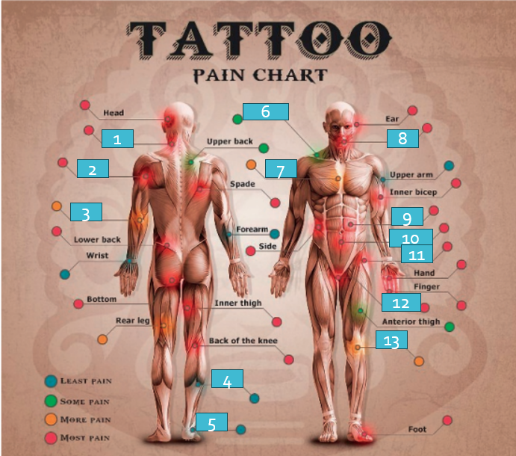

(Let’s Connect 3, p 271)

1. ……………………………..
2. ……………………………..
3. ……………………………..
4. ……………………………..
5. ……………………………..
6. ……………………………..
7. ……………………………..
8. ……………………………..
9. ……………………………..
10. ……………………………..
11. ……………………………..
12. ……………………………..
13. ……………………………..

## 3 Skincare tips

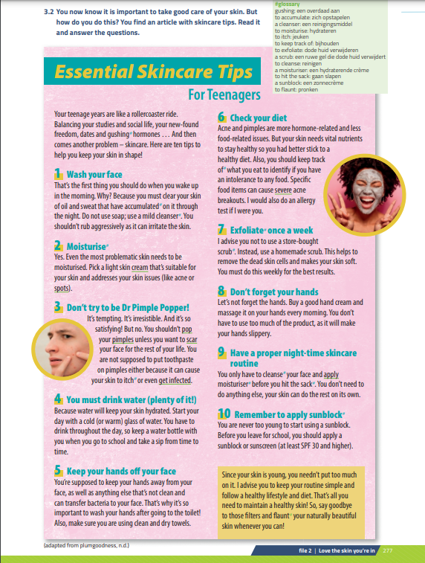

(Let’s Connect 3, 277)

(Let’s Connect 3, p 278)

## 4 Modal verbs and expressions

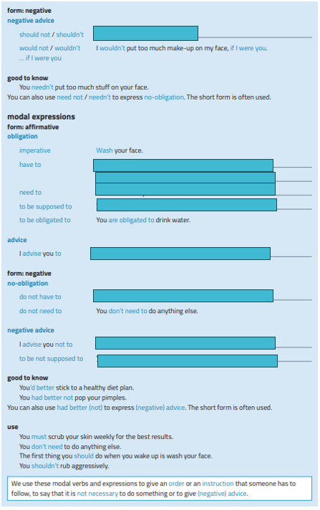

(Let's Connect 3, p 278-279)

## 5 Unusual skincare tips

- Invent 3 weird skincare tips: write them on this paper and give it to the teacher at the end of the lesson. You will receive feedback on it!  
- Use modals from the grammar box.  
  
- 5 minutes brainstorm  
- 5 minutes sharing is caring

1………………………………………………………………………………………………………………………………………………………………………………………………………………………………………………………………………………………………………………………………………………………………………………………………………………………………………………………………………………………………………………………………………………………………………………………………………………………………………………………………………………………2………………………………………………………………………………………………………………………………………………………………………………………………………………………………………………………………………………………………………………………………………………………………………………………………………………………………………………………………………………………………………………………………………………………………………………………………………………………………………………………………………………………3……………………………………………………………………………………………………………………………………………………………………………………………………………………………………………………………………………………………………………………………………………………………………………………………………………………………………………………………………………………………………………………………………………………………………………………………………………………………………………………………………………………………………………………………………………………………………………………………………………………………