ProTEEM Day 2 Part I: Worksheet – Realistic Mathematics Eduction

Exercise A
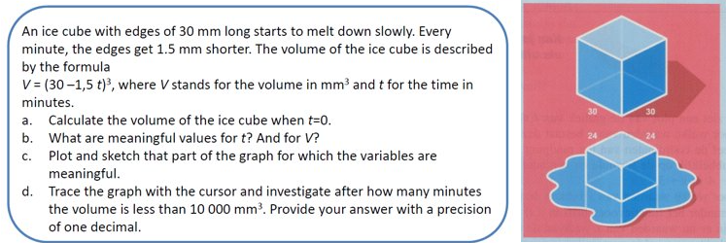

Exercise B
The temperature in a cool storage room is given by the following function:​
​ 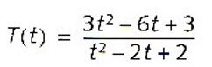
​T = temperature (°C); t = time (in hours); t = 0 corresponds to 3 a.m.​
- Sketch the graph of this function​
- If the temperature drops below 1 °C, there is a risk of damage to the food. How long was the temperature below 1 °C? From when to when?​
- When did the temperature start to rise again?​
- What temperature does the cool storage evolve to?​

Exercise C
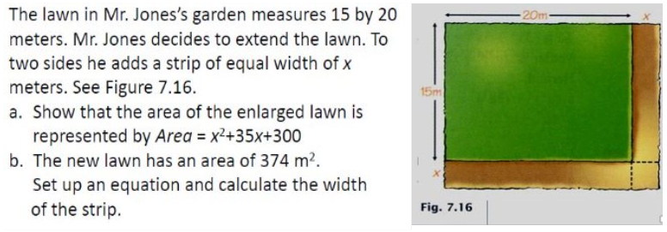
Exercise D
Mr. Kok has a lawn of 16m by 40m. His lawn machine mows 40cm wide. He starts mowing on the outside and follows the perimeter. After how many laps is he halfway?​​

